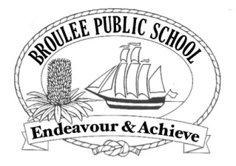

Class of 1J
Broulee Public School
Cambridge Crescent
BROULEE NSW 2537

18-9-2014

Dear Paul,

We want you and your dog Digger to come to our school and spend some time with our class, 1J.

Daniel in our class is one of your biggest fans and tells us all about your show.

We will give Digger a present like a dog bone or a toy bone.

You could help us with learning about gardening and cooking. We could show you our vegetable garden.

We have a pizza oven and we could make pizzas with you. We could make Hawaiian pizza and use some of the herbs from our garden to make them yummy.

We could show you our chickens. They lay lots of eggs for our school.

We have a playground Digger might like.

The teachers are nice.

Please come and we might let you play on the iPads.

We could give you a tour around our school.

We could give you a mug that says Broulee Public School on it.

We really want you to come so we can meet you and learn about being sustainable.

These are all the reasons we think you should come. We have been practicing our persuasive writing so we hope this persuades you to come.

From Daniel, Kiran, Hugh, Foxx, Oscar, Finn, Dein, Robert, Charlie and Kai, the boys of 1J, and Mrs Anne Jones (their teacher)

